**Group B:**

**Short Answer Questions (*Attempt any Eight questions*: ) [8*5=40]**

1. Describe how a function can be represented using a graph. Represent following graph using adjacency matrix. [2+3]

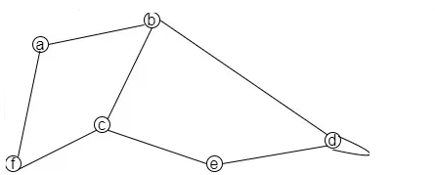

1. Define Eular path and Hamilton path with examples. Draw the Hasse diagram for the divisible relation on the set { 1, 2, 5, 8, 16, 32} and find the maximal, minimal, greatest and least element if exist. [5]
2. Prove that if n is a positive integer, then n is even if and only if n2 is even. [5]
3. Define logical connectives. Which of the following is POSET
   1. (Z ,= )
   2. (Z ,≠ )
4. Illustrate the use of the Chinese Remainder Theorem with an example. [5]
5. Find the multiplicative inverse of 4 in 𝑍11 ​ (the integers modulo 11) using the extended Euclidean algorithm. [5]
6. Prove that the product x y is odd if and only if both x and y are odd integers. [5]
7. Define ceiling and floor function. Why do we need Inclusion - Exclusion principle? Make it clear with suitable example. [2+3]
8. Define spanning tree and minimum spanning tree. Mention the conditions for two graphs for being isomorphic with an example. [2+3]

**TEXAS INTERNATIONAL COLLEGE**

**MID-TREMINAL EXAM - 2024**

**Bachelor Level (B.Sc. CSIT) Semester: 2nd Semester**

**Subject: Discrete Structure(CSC165)**

Full Mark: 60 Time: 3 hours Pass Mark :30

**SET A**

**Group A:**

**Long Answer Questions (*Attempt any Two questions*:) [2*10=20]**

1. State division and remainder algorithm and explain with example. Find the value of x such that x = 1 (mod 3), x = 1 (mod 4), x = 1 (mod 5) and x = 0 (mod 7) using Chinese remainder theorem. [4+6]
2. Determine whether the function f(x) = x2 is injective, surjective or bijective with reasons. Suppose that the domain of the propositional function P(x) consists of the integers 2, 3, 4 and 5. Write out each of following propositions using disjunctions, conjunctions and negations. [4+6]
   * + - 1. ∃x P(x)
         2. ∀x P(x)
         3. ∃x ¬P(x)
         4. ∀x ¬P(x)
         5. ¬∃x P(x)
         6. ¬∀x P(x)
3. 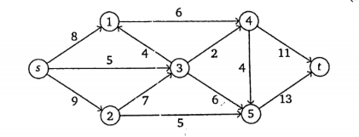(a) List and explain the conditions for two graphs to be isomorphic with an example.  
   (b) Find the maximal flow in the given network flow diagram from the SOURCE to the SINK. [5+5]

**Group B:**

**Short Answer Questions (*Attempt any Eight questions****:***) [8*5=40]**

1. Describe how relations can be represented using matrices. Show that the relation R = {(a, b): |a – b| is even} is an equivalence relation in the set of integers. [2+3]
2. Define proposition. Consider the argument: "John, a student in this class, knows how to write programs in C. Everyone who knows how to write programs in C can get a high-paying job. Therefore, someone in this class can get a high-paying job." Explain which rules of inference are used for each step. [1+4]
3. Consider a set U = { 1,2,3,4,5,6,7,8,9,10}. What will be the computer representation for set containing the numbers which are multiple of 3 not exceeding 6? [5]
4. Illustrate Dijkstra's Algorithm to find the shortest path from a source node to a destination node with an example.  
   [5]
5. What are the significances of Minimal Spanning Trees? Describe how Kruskal's algorithm can be used to find the MST.  
   [2+3]
6. Explain the principle of inclusion and exclusion. How many integers from 1 to 30 are multiples of 2 or 3?
7. Define symmetric closure. What is the symmetric closure of the relation R = {(1,1), (1,2), (2,2), (2,3), (3,1), (3,2)} on the set A = {1,2,3}? [5]
8. Prove that “If the product of two integers a and b are even then either a is even or b is even”, using the contradiction method. [5]
9. Find the GCD of 24 and 32 using Extended Euclidean algorithm. [5]

**TEXAS INTERNATIONAL COLLEGE**

**MID-TREMINAL EXAM - 2024**

**Bachelor Level (B.Sc. CSIT) Semester: 2nd Semester**

**Subject: Discrete Structure(CSC165)**

Full Mark: 60 Time: 3 hours Pass Mark :30

**SET B**

**Group A:**

**Long Answer Questions (*Attempt any Two questions:*) [2*10=20]**

1. (a) Prove that for any integers a and b, gcd(a,b) can be expressed as a linear combination of a and b.  
   (b) Find the value of maximal flow in the graph below: [5+5]

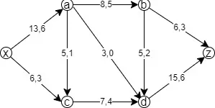

1. (a) Explain the properties of equivalence relations with examples.  
   (b) Let A = “Aldo is Italian” and B = “Bob is English”. Formalize the following sentences in proposition.
   1. Aldo isn’t Italian.
   2. Aldo is Italian while Bob is English.
   3. If Aldo is Italian then Bob Bob is not English.
   4. Aldo is Italian or if Aldo isn’t Italian then Bob is English.
   5. Either Aldo is Italian and Bob is English, or neither Aldo is Italian nor Bob is English. [4+6]
2. (a) Describe the different methods of proof with examples (direct proof, indirect proof, proof by contradiction, proof by contraposition).  
   (b) Using Kruskal's algorithm, find the minimum spanning tree for the given graph.  
   [5+5]